# “COSY AIR-CONDITIONERS”

# “Haier”

**“Models”**

**“Haier HSU 12HQA R2-DB DC Inverter”**

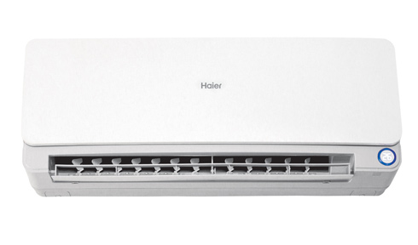

### FEATURES

* 50% Power saving
* I feel you - By detecting number and location of people in the room,airflow, air speed and temperature can be adjusted automatically
* work upto 52 ℃(T3 condition)
* wide voltage - between 175V-242V
* child lock
* Intelligent airflow
* precise system control technology
* friendly referigerant R410a
* evaporator self-cleaning

### Specifications

**Cooling ~** 12000(2400-14400)

**Heating ~** 17000(2400-23000)

**Applied Room Size(m2) ~** 14

**Power input (W) ~** 800(160-1320) Cooling | 1070(160-1790) Heating

**Running Current (A) ~** 0.9 - 6.5 in Cooling | 1 - 8.6 in Heating

**EER ~** 4.38

**“RS ~ 63,000.**

**“Haier HSU 18HZE R2”**

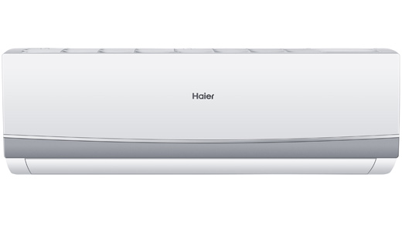

### FEATURES

* 50% Power saving
* I feel you
* wide voltage
* active PFC technology
* child lock
* precise system control technology
* Intelligent airflow
* 3D airflow
* evaporator self-cleaning
* auto mode

### Specifications

**Cooling ~** 18000 BTU ( 1 Ton )

**Power Input ~** 1470 (W)-Cooling

**EER ~** 3.4

**RS ~ 73,000.**

**“Haier HSU-12LXA03ZA (Long Throw)”**

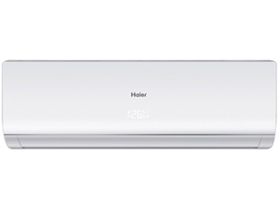

### FEATURES

* auto restart after power restored
* concealed LED display
* easy clean(indoor)
* Intelligent airflow
* child lock
* super quiet mode
* evaporator self-cleaning
* 1
* 2
* evaporator self-cleaning

### Specifications

**Cooling ~** 12000 BTU ( 1 Ton )

**Power Input ~** 1150 (W)-Cooling

**EER ~** 2.89

**RS ~ 35,500.**

### “Haier HSU-12LXA-ZC (Long Throw)” C:\Users\Sanan\Desktop\AC\Haier\Haier HSU-12LXA-ZC (Long Throw), 1 Ton.jpg

### Key Features

* Long Air Throw - Powerfull blower give you long and strong air flow, Feel the cool wind in every corner.
* Lower noise 32db give you the feeling of quiet cooling.
* concealed LED display

### Specifications

**Cooling Capacity(BTU) ~** 12000

**Applied Room Size(m2) ~** 14

**Power Input(W)-Cooling ~** 1150

**Running Current(A)-Cooling ~** 5.1

**EER ~** 2.89

**RS ~ 36,000.**

**“Haier HSU-12LKE10 (20% Saving)”**

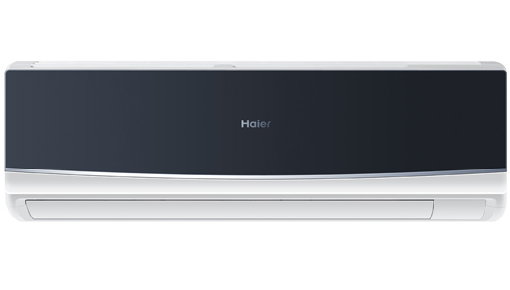

**FEATURES**

* powerful cooling
* work upto 52 ℃(T3 condition)
* 20% power saving with high energy
* concealed LED display
* child lock
* easy clean(indoor)
* power mode
* auto mode
* evaporator self-cleaning

**Specifications**

**Cooling Capacity** 12000 BTU ( 1 Ton )

**Power Input** 1190 (W)-Cooling

**RS ~ 38,500.**

**“Haier HSU-18LKE8A (20% Saving)”**

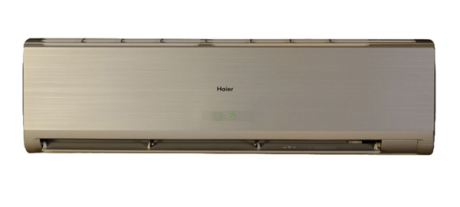

### FEATURES

* 20% power saving with high energy
* work upto 52 ℃(T3 condition)
* auto restart
* concealed LED display
* child lock
* easy clean(indoor)
* Intelligent airflow
* super quiet mode
* evaporator self-cleaning
* Inner brass screw high efficiency

### Specifications

**Cooling ~** 18000 BTU ( 1.5 Ton )

**Cooling Capacity ~** 4700 (BTU)

**Heating Capacity ~** 750 (BTU)

**Power Input ~** 1518 (W)-Cooling

**EER ~** 3.1

**RS ~ 48,000.**

**“Haier HSU-18LEK E2 (Rapid Cooling)”**

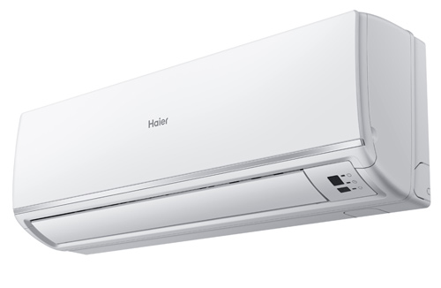

### FEATURES

* work upto 52 ℃(T3 condition)
* auto restart after power restored
* child lock
* easy clean(indoor)
* Intelligent airflow
* evaporator self-cleaning

### Specifications

**Cooling Capacity ~** 18000 (BTU)

**Heating Capacity ~** No

**Applied Room Size ~** 21 (m2)

**Power Input ~** 2000 (w) while Cooling

**Running Current ~** 9.6 (A) Cooling

**EER ~** 2.45

**RS ~ 47,500.**

**“Haier HSU-18LEK E6 (Rapid Cooling)”**

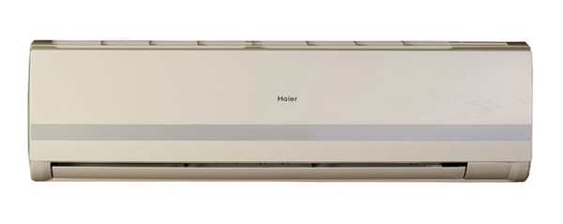

### FEATURES

* powerful cooling
* work upto 52 ℃(T3 condition)
* auto restart
* concealed LED display
* child lock
* easy clean(indoor)
* Intelligent airflow
* super quiet mode
* evaporator self-cleaning

### Specifications

**Cooling ~** 18000 BTU ( 1.5 Ton )

**Cooling Capacity ~** 4800 (BTU)

**Heating Capacity ~** 750 (BTU)

**Power Input ~** 1914 (W)-Cooling

**EER ~** 2.51

**RS ~ 46,500.**